Private Reading Room

INTRODUCTION
The Reading Room on the ground floor has become a Private Reading Room for committee evidence.
Initially this was for the Vision Nine Committee evidence. It has also been used for banking evidence and now holds the PAC - Salisbury Street Tender Documents.

Access to the room
The Committee determines what access should be set up in relation to the files.

The room must remain locked at all time when it holds evidence.

The key to the Reading Room is in the key collection in the safe room.

by non-Tynwald Members
The room will still house the Law Society volumes.
If a Law Society member wants to use the room, the committee evidence must be removed.
The evidence must be taken out of that room temporarily and stored in the room with the safe.

By non-Committee Members
Any questions or queries about the evidence please direct the Member to the assistant clerk to the committee or the clerk to the committee

Examples of restricted Access previously used

Vision Nine
This can be accessed by any Tynwald Member on receipt of a signed disclosure form.
In the bottom draw there is a pink folder with a sign in sheet, a declaration and a key in it.
The members must sign for the key and sign the declaration before going into the Private Reading Room.

EPRC Banking
TAO manage access
Committee Members - http://www.tynwald.org.im/business/committee/EPRC/

PAC - Salisbury Street Tender Documents
Access available to all PAC Committee Members:
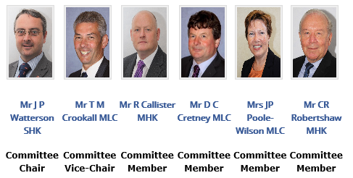
Any questions or queries about the evidence please direct the Member to Nina (Assistant Clerk to the Committee) or Jo (Clerk to the Committee)

